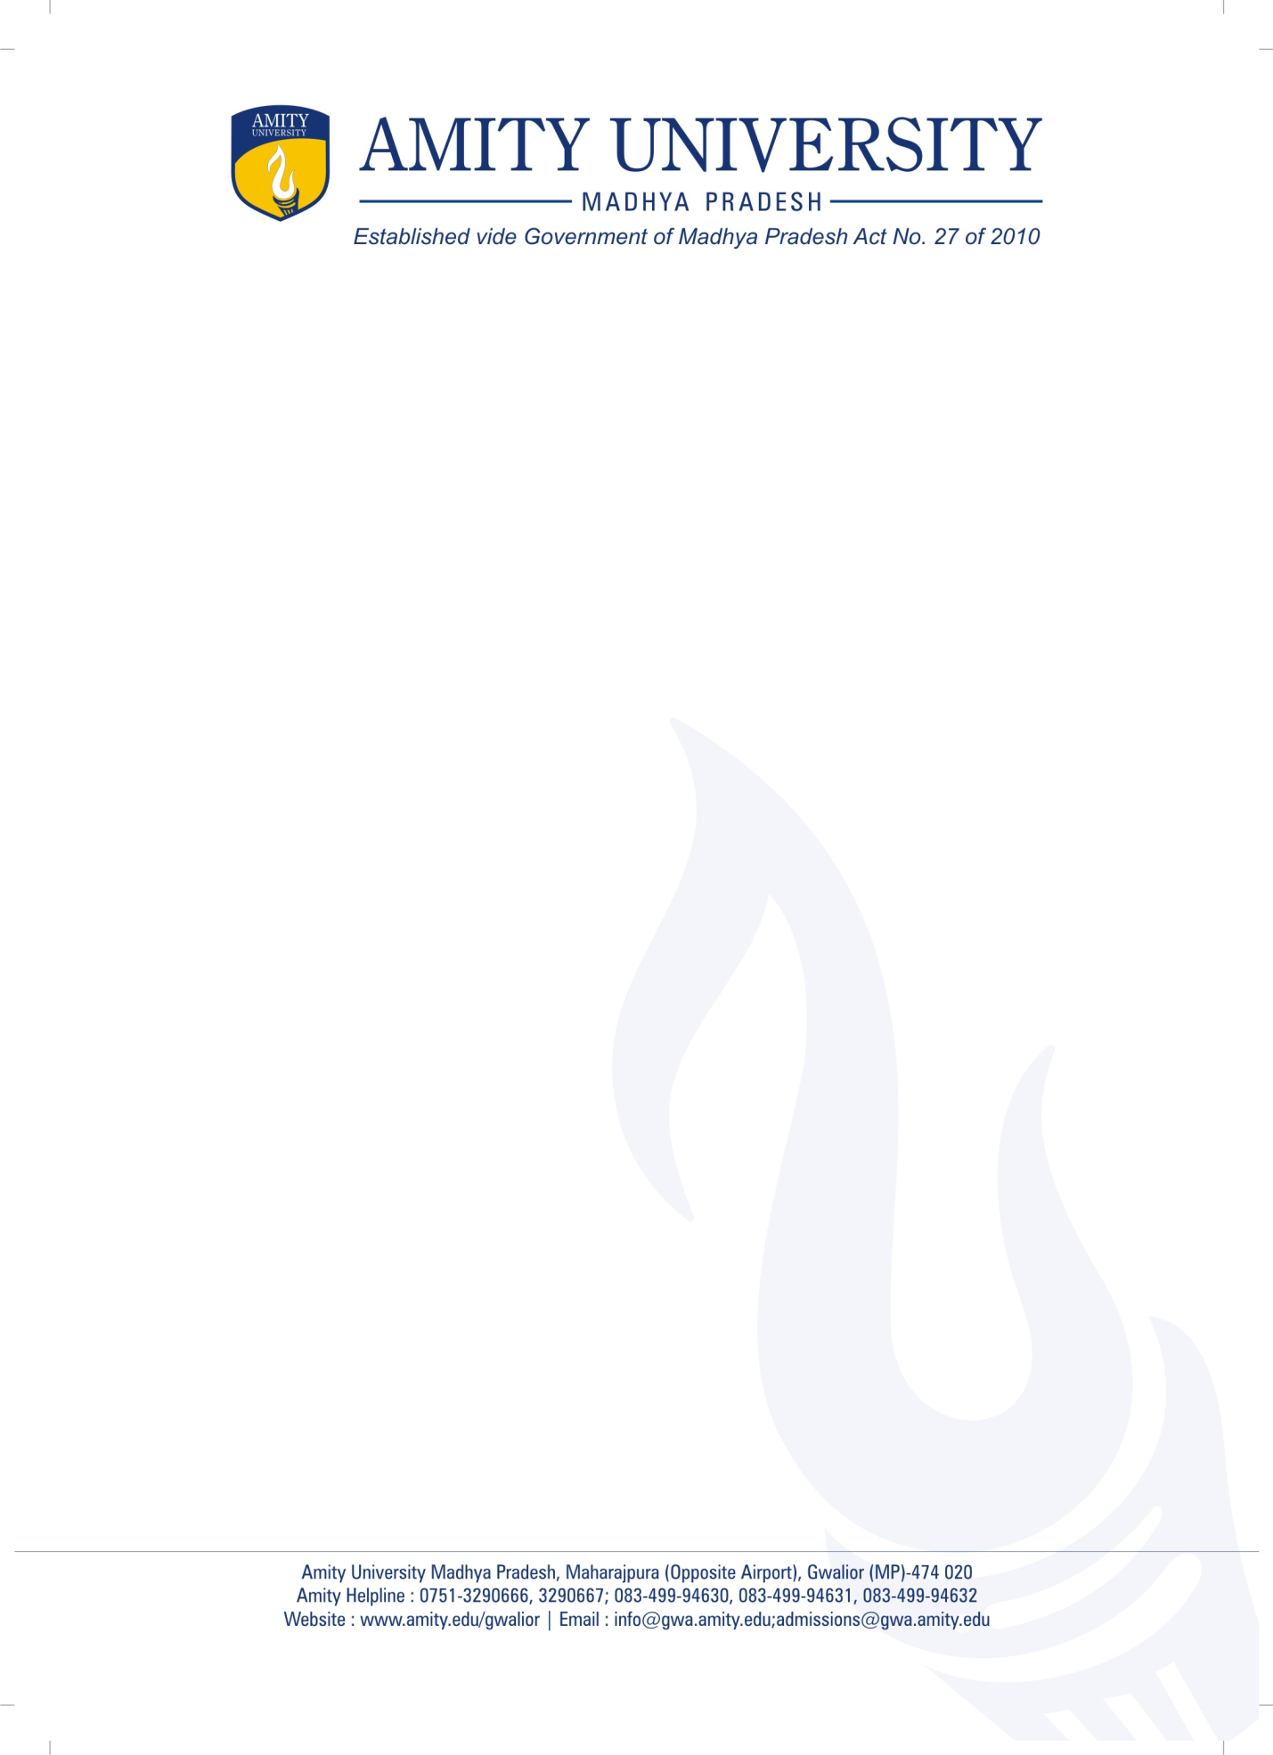
AMITY SCHOOL OF ENGINEERING & TECHNOLOGY
BANK ACCOUNT DETAILS FOR HONORARIUM TO THE GUEST SPEAKER
S.No. | Name as per Bank Account | A/C No. | IFS Code | Bank Address

Name of Event ____________________________________________
Date __________________

Name & Signature of Guest Speaker: __________________________
________________________________________________________

Signature & Name of Event Coordinator_______________________

Director-ASET_____________________________
Date_________________

